TENSAS BASIN LEVEE DISTRICT
April 14, 2015

The Board of Commissioners of the Tensas Basin Levee District met for its regular meeting
Tuesday, at 9:30 A. M. in its office located at 505 District Drive Monroe, Louisiana.

Mr. Drew Keahey, President, called the meeting to order and requested the Secretary
call roll with the following present and answering: Mr. Drew Keahey, President, Caldwell Parish; Mr. Rodney Hutchins, Vice President, Catahoula Parish; Mr. Charles Venable, Mr. James Mayo and Mr. Mike Calloway, Ouachita Parish; Ms. Ramona N. Haire and Mr. Robert Neal Harwell, Richland Parish; Mr. Venoy Kinnaird, Morehouse Parish; Mr. Harlon Nobles, LaSalle Parish and Mr. Ashley Peters, Franklin Parish. Absent: Mr. Shelton Ruffin, West Carroll Parish.

Others in attendance were: Mr. Ryan McMillian and Mr. Sam Hodge, Department of Transportation and Development, Monroe, La.; Mr. John Stringer, Executive Director, Tensas Basin Levee District; Mr. Johnny Trisler, Maintenance Supervisor, Tensas Basin Levee District, Mr. Tracy Hilburn, Maintenance Supertendant, Tensas Basin Levee District and Mr. Brandon Waggoner, Levee District Police

Commissioner Rodney Hutchins opened the meeting with prayer being followed by Mr. Tracy Hilburn leading in Pledge of Allegiance.

The following resolution was introduced by Commissioner Ramona N. Haire, seconded by
Commissioner Mike Calloway, and passed unanimously by the Board of Commissioners of the Tensas Basin Levee District, after President Drew Keahey called for public comments and there were none, to-wit:

RESOLUTION

NOW, THEREFORE, BE IT RESOLVED that the Board of Commissioners of the Tensas
Basin Levee District does hereby declare that the reading of the minutes of the regular meeting
of February 10, 2015 is hereby dispensed with and declared approved as published in the official journal of this board, The Richland Beacon News.

Virginia Caviness Drew Keahey
Secretary President

The following resolution was introduced by Commissioner Harlon Nobles, seconded by
Commissioner Ramona N. Haire, and passed unanimously by the Board of Commissioners of the Tensas Basin Levee District, after President Drew Keahey called for public comments and there were none, to-wit:

RESOLUTION

NOW, THEREFORE, BE IT RESOLVED that the Board of Commissioners of the Tensas
Basin Levee District does hereby approve all bills approved by the claims committee for March and April, 2015.

Virginia Caviness Drew Keahey
Secretary President

The following resolution was introduced by Commissioner Mike Calloway, seconded by
Commissioner Charles Venable, and passed unanimously by the Board of Commissioners of the Tensas Basin Levee District, after President Drew Keahey called for public comments and there were none, to-wit:

RESOLUTION

NOW, THEREFORE, BE IT RESOLVED that the Board of Commissioners of the Tensas Basin Levee District does hereby authorize the transfer of the following campsites:

WBS-2 from Shane Craig to Donald and Debra King.
JB-04 from Trent Hines to Chad Smith.

Virginia Caviness Drew Keahey
Secretary President
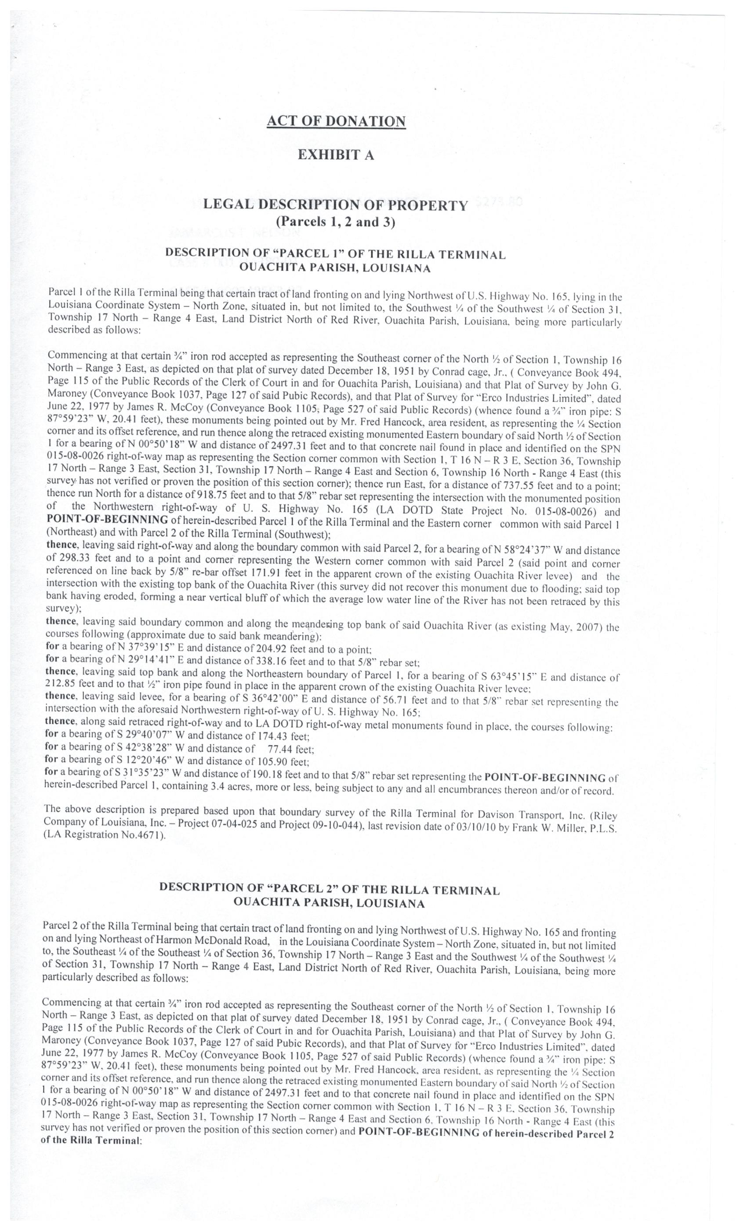
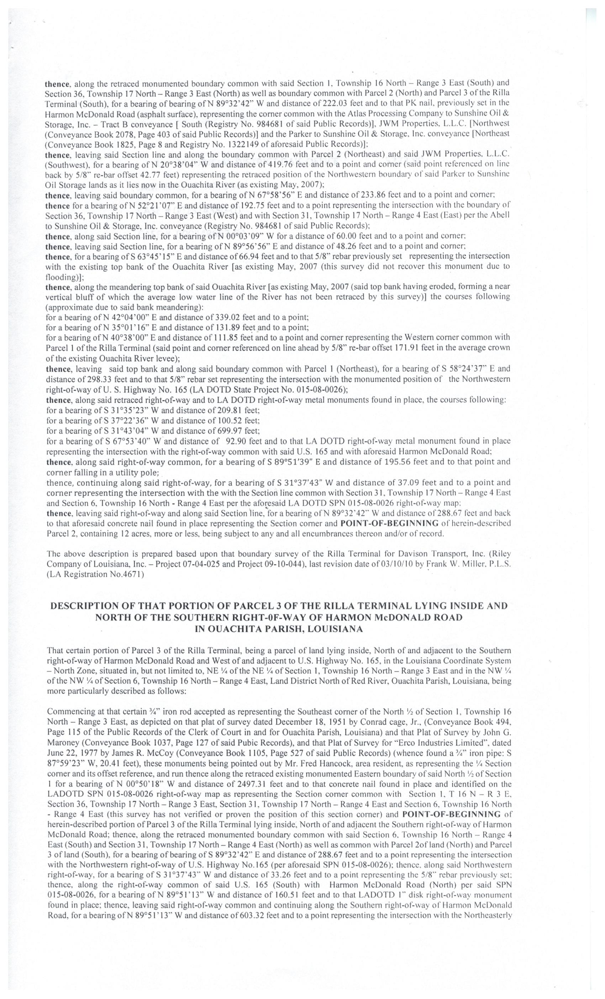
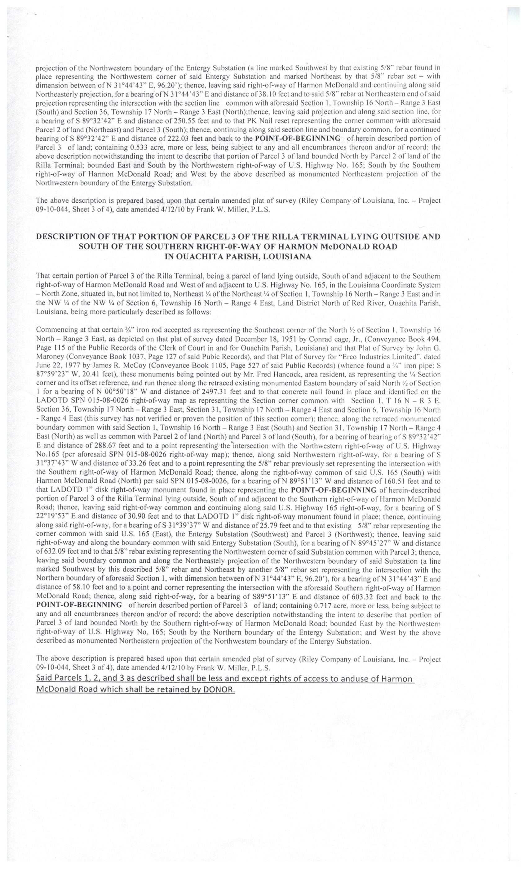
President Keahey advised of the above donation of approximately sixteen and one-half acres of land located in Ouachita Parish by Genesis Energy, Houston, Texas for levee improvements.

The following resolution was introduced by Commissioner Rodney Hutchins, seconded by
Commissioner Venoy Kinnaird, and passed unanimously by the Board of Commissioners of the Tensas Basin Levee District, after President Drew Keahey called for public comments and there were none, to-wit:

RESOLUTION
NOW, THEREFORE, BE IT RESOLVED that the Board of Commissioners of the Tensas Basin Levee District does hereby authorize all campsite leases shall be for a three year period commencing January 01, 2016 and for three years thereafter until changed in accordance with RS38:320 of the State of Louisiana.

Virginia Caviness Drew Keahey
Secretary President

Mr. John Stringer, Executive Director gave an up-to-date report on bank cavings along the Ouachita River and needed corrective action in the future. Mr. Stringer, Mr. Keahey, Mr. Hilburn and Mr. Trisler advised the Levee District is in a flood fight situation. Mr. Stringer and Mr. Keahey thanked Mr. Hilburn and Mr. Trisler and their crews for an outstanding jobs done in the flood fight and the handling thereof.

Financial reports and Levee District Police reports were reviewed and discussed after President Drew Keahey called for public comments and there were none.

President Drew Keahey called for public comments and there were none.

President Drew Keahey advised the Board of Commissioners of the Tensas Basin Levee District will hold an open meeting, Tuesday, May 12, 2015 at 9:30 A. M., at our office at 505 District Drive, Monroe, Louisiana to adopt the millage rate for 2015.

President Drew Keahey declared that there being no further business to come before the Board of Commissioners of the Tensas Basin Levee District at this time, the meeting is adjourned.

Virginia Caviness Drew Keahey
Secretary President

